Data Analytics (DA)

(Module-End -3) Module End Assignment

“Analyzing E-Learning Platform Purchases using MySQL”

Assignment Task Overview

Problem Statement:
An online learning platform sells various digital courses to learners across different countries. Each learner can purchase multiple courses, and each course belongs to a specific category.
The management team wants to analyze purchase data to understand sales trends, learner behavior, and popular course categories.
Your task is to use MySQL to design and query a relational database that helps derive meaningful insights from this e-learning purchase data.

Dataset Description:
You will work with the following three tables:
- Table: learners
Attributes:
  - learner_id (Primary Key)
  - full_name
  - Country
- Table: courses
Attributes:
  - course_id (Primary Key)
  - course_name
  - category
  - unit_price
- Table: purchases
Attributes:
  - purchase_id (Primary Key)
  - learner_id (Foreign Key → learners.learner_id)
  - course_id (Foreign Key → courses.course_id)
  - Quantity
  - purchase_date
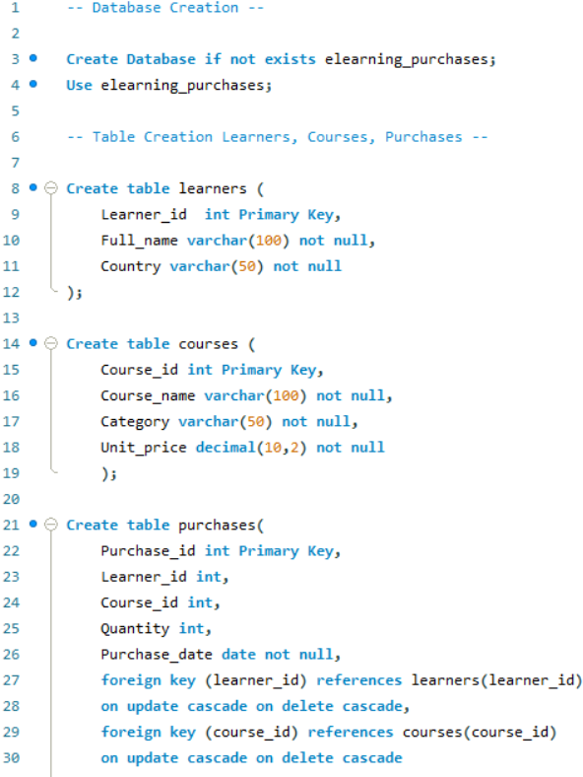

Tasks

1. Create the database and schema. Populate the Schema:
- Create a Database for this project and
Create all three tables in MySQL with appropriate data types and relationships.
- Insert sample data covering at least:
  - 4–5 learners
  - 4–5 courses (spread across multiple categories)
  - 6–8 purchase records
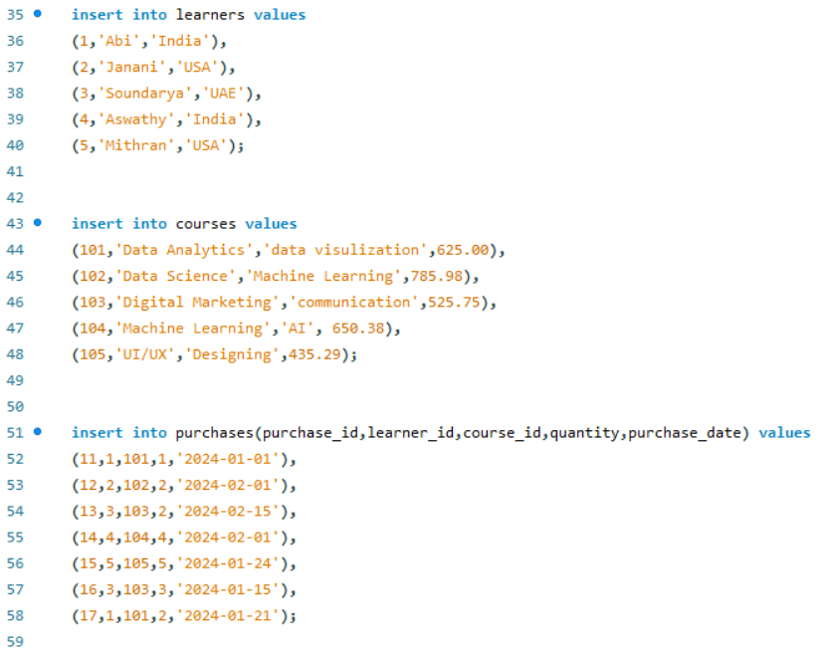

2. Data Exploration Using Joins
Data Presentation Guidelines for the following query
- Format currency values to 2 decimal places.
- Use aliases for column names (e.g., AS total_revenue).
- Sort results appropriately (e.g., highest total_spent first).
Use SQL INNER JOIN, LEFT JOIN, and RIGHT JOIN to:
- Combine learner, course, and purchase data.
- Display each learner’s purchase details (course name, category, quantity, total amount, and purchase date).

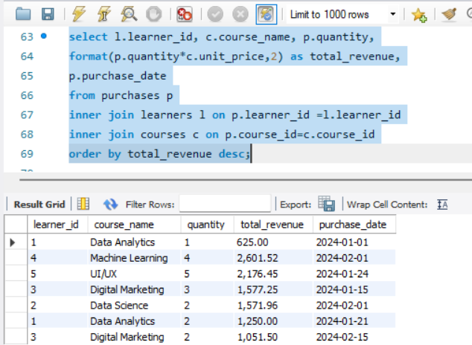
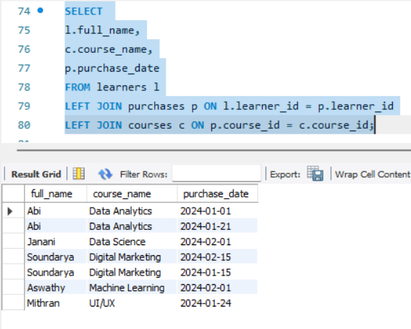
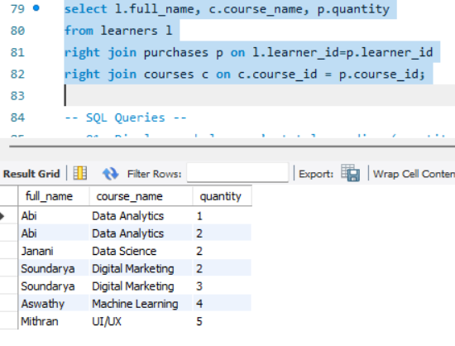

3. Analytical Queries
Write SQL queries to answer the following questions:
Q1. Display each learner’s total spending (quantity × unit_price) along with their country.
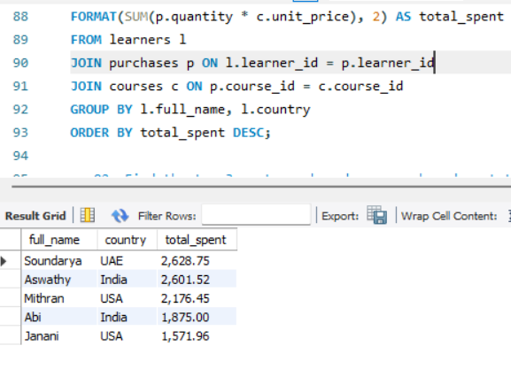
Q2. Find the top 3 most purchased courses based on total quantity sold.
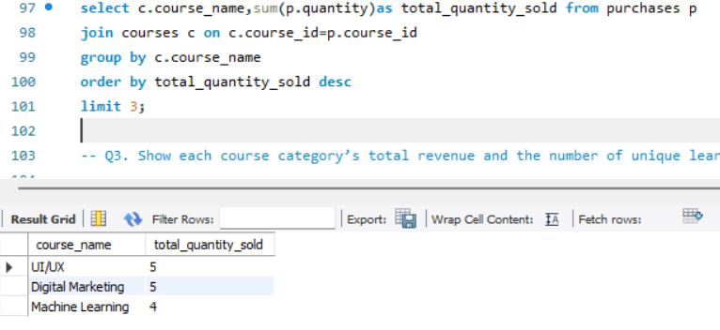
Q3. Show each course category’s total revenue and the number of unique learners who purchased from that category.
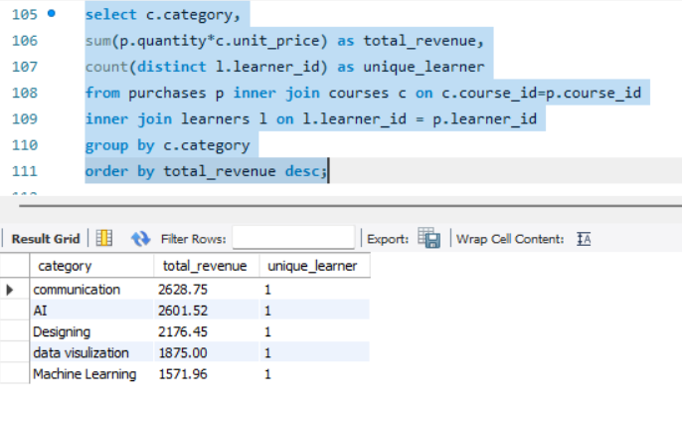
Q4. List all learners who have purchased courses from more than one category.
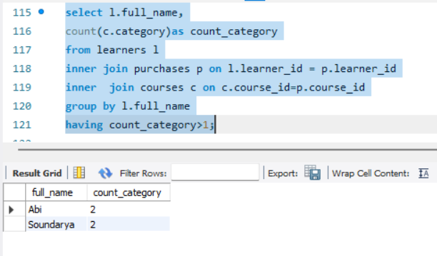
Q5. Identify courses that have not been purchased at all.
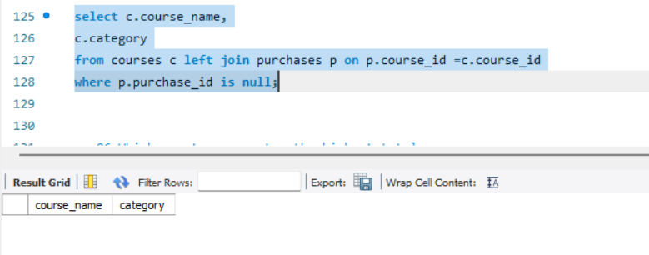
Q6. Which country generates the highest total revenue
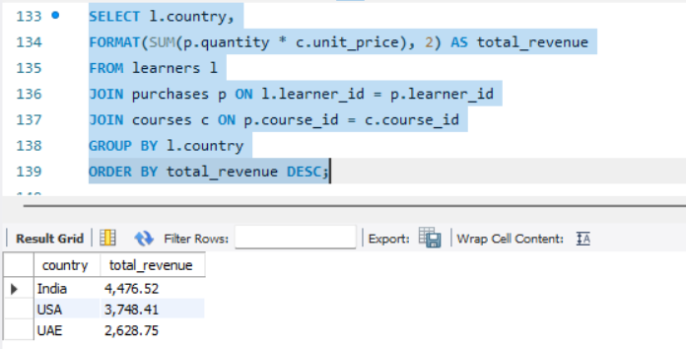
Q7. Find the least purchased course by total quantity code
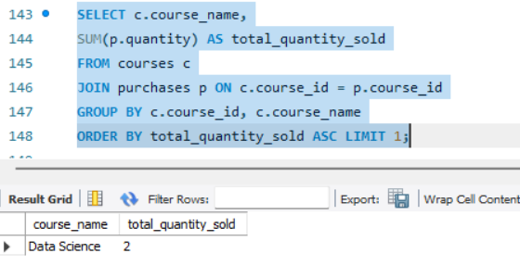
Q8. First Purchase Date of Each Learner
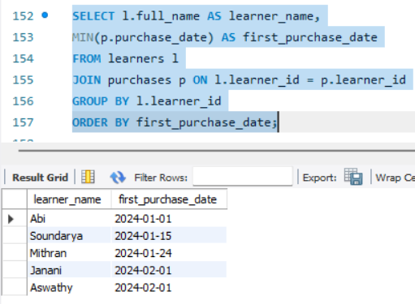
Q9. Learners Who Made Only One Purchase
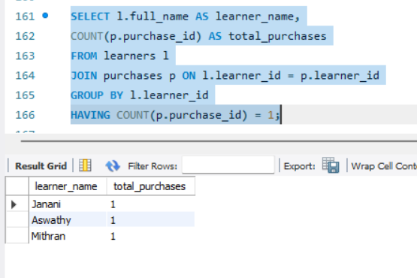
Q10. Which category has the highest average course price
